**Data Assembly for Input into IVEN Pipeline**  
January 2020  
Jessica E. Forsyth

This tutorial summarises how data must first be organised prior to input into the IVEN pipeline (Python or MATLAB versions). The current data import works under the assumption that data is organised in the following order. Should the data not be correctly organised IVEN will not process data as originally intended.

Data organisation can be time consuming when handling large numbers of files, we therefore suggest that you generate your own macros in Excel to organise your data accordingly. We have developed macros for use with older IMARIS versions and the latest IMARIS software. These are available on request.

IVEN uses spatial data of segmented/detected cell nuclei/centres in order to classify cells and calculate the number of neighbours. Alongside this, IVEN allows for the visualisation of staining intensity. Therefore the data required by IVEN is; cell ID, spatial coordinates, channel intensities, corrected channel intensities.

Cell ID: a way of identifying each individual cell, this is automatically output during IMARIS segmentation but can be allocated manually during data organisation if your method of image segmentation does not allocate cells with an identifier.

Spatial coordinates: the x, y, and z coordinates of the cell centre/nucleus. This should be output from your segmentation software.

Channel intensities: this refers to the intensities associated with the immunofluorescence of a given staining. For this we include the blue, green, red, and far-red channels. In our stainings we use the blue channel for nuclear staining and so this is not displayed explicitly in IVEN.

Corrected channel intensities: due to the depth of the preimplantation embryo, there is some attenuation of fluorescent signals when imaging. We therefore correct the green, red and far-red channels with respect to Hoechst. As our nuclear marker Hoechst should expressed similarly across all cells within the embryo, any attenuation or change in intensity of Hoechst can be assumed to be due to the depth attenuation of the sample. We therefore divide the raw intensity values of the green, red and far-red channels by the Hoechst intensity. This is a crude method of accounting for attenuation, but sufficient for the relative visualisations of channel intensity within IVEN.

Should your sample not require this correction, then the raw channel intensities can just be copied into the corrected channel intensity columns. Alternatively if you have a different method of depth correction, you can use this for your corrected channel intensities.

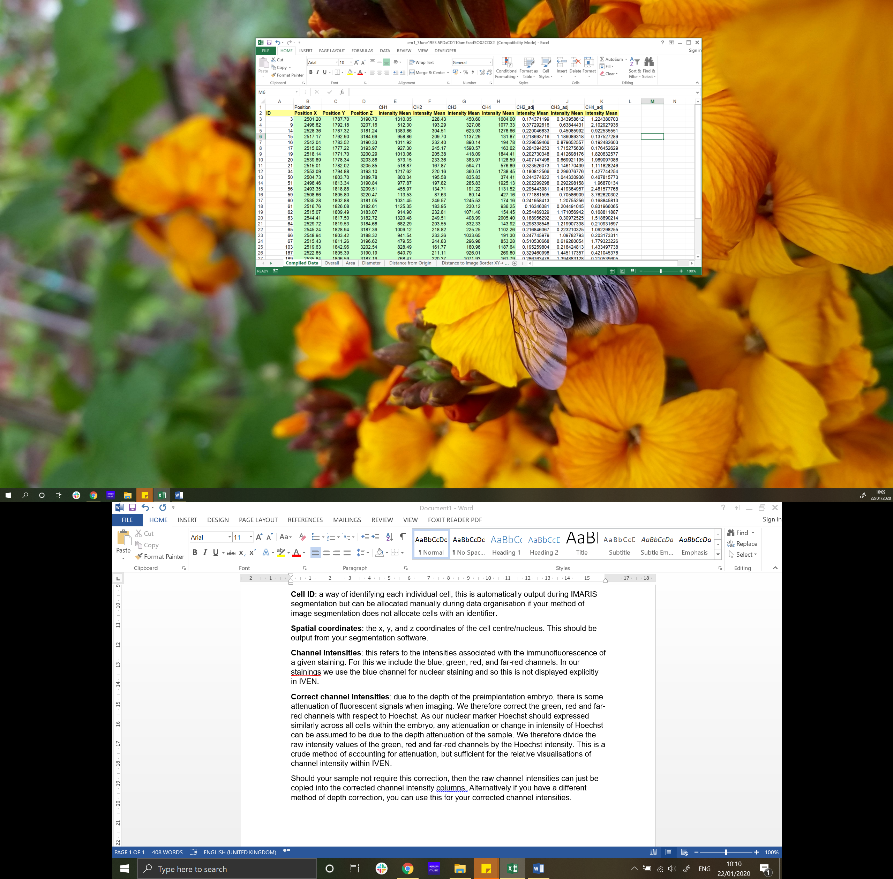An example of compiled data-

**Pipeline for data assembly/organisation**

1. Collect images of sample, using confocal or equ.
2. Using IMARIS or your own segmentation method, identify cell centres, channel intensities and label cells with identifiers if not automatically performed by the segmentation software.
3. Copy data into correct columns;
   1. Column 1 : Cell ID
   2. Column 2 : x coordinate of cell centre/nucleus
   3. Column 3 : y coordinate of cell centre/nucleus
   4. Column 4 : z coordinate of cell centre/nucleus
   5. Column 5 : Channel 1 intensity (mean/median – whatever you want)
   6. Column 6 : Channel 2 intensity (mean/median – whatever you want)
   7. Column 7 : Channel 3 intensity (mean/median – whatever you want)
   8. Column 8 : Channel 4 intensity (mean/median – whatever you want)
   9. Column 9 : Corrected channel 2 intensity (using whatever method you prefer)
   10. Column 10 : Corrected channel 3 intensity (using whatever method you prefer)
   11. Column 11 : Corrected channel 4 intensity (using whatever method you prefer)
4. If for instance you have only imaged two channels (green and red), simply fill columns 8 and 11 with a series of ones. This is therefore not real data and clearly identifiable during analysis. However this makes the input of data into IVEN simpler and guaranteed to be accurate in data organisation.   
   **(REMEMBER YOU CAN WRITE A MACRO TO DO THIS ALL FOR YOU!)**
5. Save data as an **Excel 97-2003 Workbook**, this is important.
6. You are now ready to run IVEN! See either the Python tutorial or MATLAB tutorial depending on which platform you decide to use.